ITSM Requirements and Design Document
Avoid Duplicate Requests and Notifications to End users when Request is submitted from DWP.

Table of Contents

Document Revision History 3
New Requirements and Design Options 4
Workflow Customizations 6

Document Revision History
Item | Date | User | Details
1 | 3/24/2021 | Amareswar Panuganti | Created – Requirements/Design
2
3

New Requirements and Design Options
For each requirement identified, one or more proposed solutions to address it will be documented along with an estimation of time required for each option. The Requester is being asked to fill out the Requirement Description, Requester, and the Priority fields.

The priority rating should be set by the Requester using the following rating scale:

Priority Rating | Description
High | There is a strong business justification and it should be implemented as soon as possible
Medium | There is a business justification, but there is not an extreme urgency to complete it immediately
Low | This is a nice to have, but should be evaluated with other work efforts for implementation

The Level of Effort (LOE) field is meant to capture a high level of effort to address the Requirement.

LOE | Description
0 | Functions without configuration
1 | Less than one day
2 | More than one day, but less than a week
3 | More than one week, but less than two weeks
4 | More than 2 weeks

Avoid Duplicate Requests and Notifications to End users when Request is submitted from DWP.
Requirement ID |  |  | REQ - 01
Requirement Description
When End users submit requests from DWP service catalog, the end users will see two req’s for same request. One would be DWP req (1234) and another one would be SRM Req number (REQxxxxxxx123). This will also trigger duplicate notifications to end users.

This will happen when we have Create Request on Submit is set Yes for respective modules.

The Requirement is to avoid duplicate SRM request and SRM Notifications to End user.

Proposed Solution
Solution 1:
- Customize OOB filter workflow for each module, this customization will make sure if request is submitted from DWP then SRM REQ is not created in backend for Incident/Work order/Change. If the same request is submitted from SMART-IT SRM REQ will be created.
- Disable any SRM notifications OOB.

Approved Solution
Solution 1

Requester | HRBINC | Priority Rating | Medium
Satisfied By | Customization | Estimated LOE | 1
Assumptions/Risks
Assumption(s):

Risk(s):

Workflow Customizations
Filter Name | Changes made
INT:SRMHPD:INC:CreateRequest_610_Submit | Add below to OOB Runif  AND ($USER$ != "hannah_admin") AND ($CLIENT-TYPE$ != 0)
INT:SRMCHG:CRQ:CreateRequest_650_Submit | Add below to OOB Runif  AND ($USER$ != "hannah_admin") AND ($CLIENT-TYPE$ != 0)
WOI:WOI:CreateRequest_650_Submit | Add below to OOB Runif  AND ($USER$ != "hannah_admin") AND ($CLIENT-TYPE$ != 0)
WOI:WOI:CreateRequest_650_Submit_NoWorkLog | Add below to OOB Runif  AND ($USER$ != "hannah_admin") AND ($CLIENT-TYPE$ != 0)

Look with below Search Criteria in Sys:Notification Messages form

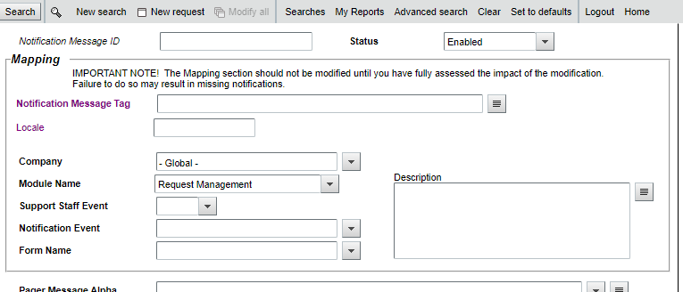

Disable anything that are associated to SRM:Request, survey and leave work order or smart-it ones alone.
All the below notifications are disabled OOB under Global Company
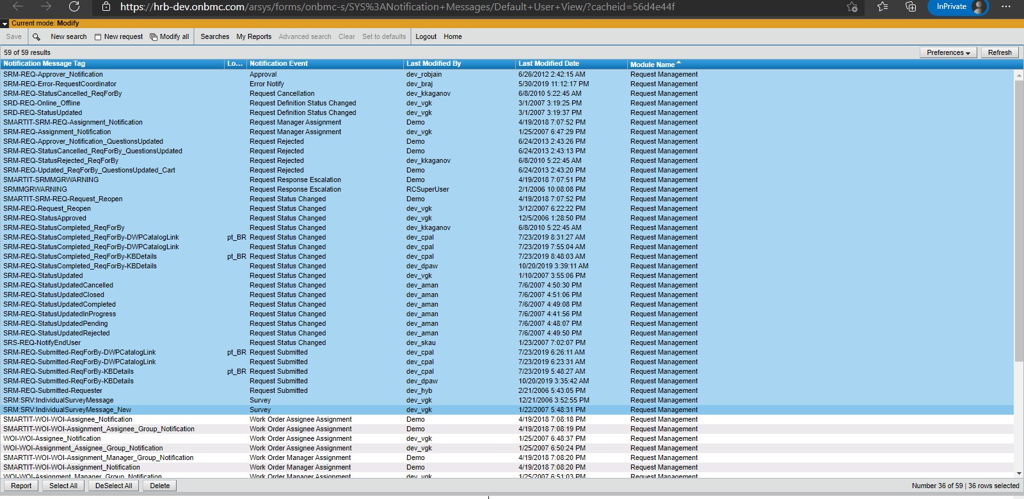

All the 36 records above have been offline at HRB environment.
